

**Dr. D. Y. Patil Vidya Pratishthan Society’s**

**DR. D. Y. PATIL INSTITUTE OF TECHNOLOGY**

**(DIT), PIMPRI, PUNE.**

**2022-2023.**

**DEPARTMENT OF COMPUTER ENGINEERING**

### A PROJECT REPORT ON

**5G TECHNOLOGY**

Submitted for partial fulfillment of the requirements for the subject

Business Communication Skill Laboratory (SE, IST Semester)

of

BACHELOR OF ENGINEERING

BY

MR. MRUNAL RAMESH SOMANKAR



Dr. D. Y. Patil Vidya Pratishthan Society’s

DR.D.Y. PATIL INSTITUTE OF TECHNOLOGY, PIMPRI, PUNE-411018

## CERTIFICATE

This is to certify that the project entitled **“5G TECHNOLOGY”** completed and submitted by

MRUNAL SOMANKAR(SCOA31)

This Business Communication Skill Laboratory project on the topic of **5G TECHNOLOGY** under my guidance, during academic session FE 2021-2022 as per the guideline’s issues by Savitribai Phule Pune University.

DATE:

PLACE: DR.D.Y.PATIL, PIMPRI, PUNE -18

(Prof.Vasudha Phaltankar) (Dr. Lalit K.Wadhwa)

Project Guide Principal

# Acknowledgement

The success and final outcome of this project required a lot of guidance and assistance from many people and we are extremely privileged to have got this all along the completion of my project. All that we have done is only due to such supervision and assistance and we would not forget to thank them.

We heartily thank our principal **Dr. Lalit K.Wadhwa** for providing such platform to us for showing our internal skills and for encouraging us.

We respect and thank **Prof.Vasudha Phaltankar**, for providing me an opportunity to do the project and giving us all support and guidance, which made us complete the project duly. we are extremely thankful for providing such a nice support and guidance

We are thankful to and fortunate enough to get constant encouragement, support and guidance from all Teaching staffs of first year Department which helped us in successfully completing our project work. Also, I would like to extend our sincere esteems to all staff in laboratory for their timely support*.*

:-

MRUNAL R. SOMANKAR (SCOA31)

# ABSTRACT

# 

# 5G technologies will change the way most high bandwidth users access their phones. With 5G pushed over a VOIP-enabled device, people will experience a level of call volume and data transmission never experienced before.5G technology is offering the services in Product Engineering, Documentation, supporting electronic transactions (e-Payments, e-transactions) etc. As the customer becomes more and more aware of the mobile phone technology, he or she will look for a decent package all together, including all the advanced features a cellular phone can have. Hence the search for new technology is always the main motive of the leading cell phone giants to out innovate their competitors. Recently apple has produced shivers all around the electronic world by launching its new handset, the I-phone. Features that are getting embedded in such a small piece of electronics are huge.

**Table Of Content**

1. INTRODUCTION TO 5G TECHNOLOGY

1.1 DEFINITION

1.2 PROPERTIES

2. EVOLUTION FROM 1G TO 5G

2.1 1 ST GENERATION

2.2 2 ND GENERATION

2.3 3 RD GENERATION

2.4 4 TH GENERATION

2.5 5 TH GENERATION

2.6 COMPARISION OF ALL GENERATION

3. KEY CONCEPT

4. ARCHITECTURE OF 5G

4.1 TERMINAL DESIGN

4.2 COMPARISION WITH OSI MODEL

4.3 OPEN WIRELESS ARCHITECTURE (OPA)

4.4 NETWORK LAYER

4.5 OPEN TRANSPORT PROTOCOL (OTP)

4.6 APPLICATION LAYER

4.7 FUNCTIONAL ARCHITECTURE

5.HARDWARE AND SOFTWARE OF 5G

5.1 HARDWARE OF 5G

5.2 SOFTWARE OF 5G

6.FEATURES, ADVANTAGES & APPLICATIONS

6.1 FEATURES

6.2 ADVANTAGES

6.3 APPLICATIONS

7.CONCLUSION BIBLIOGRAPHY

**Chapter I: INTRODUCTION**

The world has seen a lot of changes in the realm of communication. Today we no more use landlines. Everyone possesses a mobile phone that functions 24X7. Our handsets not only keep us connected with the world at large but also serve the purpose of entertainment gadget. From 1G to 2.5G and from 3G to 5G this world of telecommunications has seen several improvements along with improved performance with every passing day.

The 5th generation is envisaged to be a complete network for wireless mobile internet, which has the capability to offer services for accommodating the application potential requirements without suffering the quality. The goal of 5G is to design a real wireless world, that is free from obstacles of the earlier generations.

5G technology will change the way cellular plans are offered worldwide. A new revolution is about to begin. The global cell phone is around the corner. The global mobile phone will hit the localities who can call and access from one country to another’s local phone with this new technology. The way in which people are communicating will altogether upgrade. The utilization of this gadget will surely move a step ahead with improved and accessible connectivity around the world. Your office will shrink into your handset with this cell phone that is going to resemble PDA (personal digital assistant) of twenty first century.

5G technology has a bright future because it can handle best technologies and offer priceless handset to their customers. May be in coming days 5G technology takes over the world market. 5G Technologies have an extraordinary capability to support Software and Consultancy. The Router and switch technology used in 5G network providing high connectivity. The 5G technology distributes internet access to nodes within the building and can be deployed with union of wired or wireless network connections. The current trend of 5G technology has a glowing future.

**1. DEFINITION**

5G Wireless System is a complete wireless communication with almost no limitation; somehow people called it REAL wireless world. But till present day 5G wireless system concept is only theory and not real, so it is not applicable for use.

5G (5th generation mobile networks or 5th generation wireless systems) is a technology used in research papers and projects to denote the next major phase of mobile telecommunication standards beyond 4G. 5G is not officially used for any specification or official document yet made public by telecommunication companies or standardization bodies. New standard releases beyond 4G are in progress by standardization bodies, but are at this time not considered as new mobile generations but under the 4G umbrella. The implementation of standards under a 5G umbrella would likely be around the year of 2020.

**2. PROPERTIES**

* Worldwide cellular phone: Phone calls in any country can be done easily like a local phone call.
* Extraordinary data capabilities: Data capabilities of the 5G system is much higher than other generation so you can store more amount of data with less problem in storing them. www.studymafia.org
* High connectivity: Connectivity speed of 5G is almost 25 Mbps.
* More power & features in hand held phones: You'll have all features of PDA & laptops in your mobile phone, which makes it more powerful.
* Large phone memory, more dialing speed, more clarity in audio & video

### CHAPTER II: EVOLUTION FROM 1G TO 5G

### 1ST GENERATION

### First Generation wireless technology (1G) is the original analog (An analog or analogue signal is

### any continuous signal for which the time varying feature (variable) of the signal is a representation of

### some other time varying quantity), voice-only cellular telephone standard, developed in the 1980s.

### The prominent ones among 1G system were advanced mobile phone system (AMPS), Nordic mobile

### telephone (NMT), and total access communication system (TACS).

### The Evolution of Mobile Wireless Technology from 0G to 5G ...

### 

### Fig. 1G Mobile

### Developed in 1980s & completed in early 1990s

### Based on analog system

### Speed up to 2.4 kbps

### AMPS (Advance Mobile Phone System) was launched by the US & i was the 1G mobile system

### Allows user to make voice calls in 1 country

### 2 ND GENERATION

### 2G (or 2-G) is short for second-generation wireless telephone technology. Second generation 2G cellular telecom networks were commercially launched on the GSM standard in Finland in 1991. 2G network allows for much greater penetration intensity. 2G technologies enabled the various mobile phone networks to provide the services such as text messages, picture messages and MMS (Multi Media Messages). 2G technology is more efficient. 2G technology holds sufficient security for both the sender and the receiver. All text messages are digitally encrypted. This digital encryption allows for the transfer of data in such a way that only the intended receiver can receive and read it.

### Second generation technologies are either time division multiple access (TDMA) or code division multiple access (CDMA). TDMA allows for the division of signal into time slots. CDMA allocates each user a special code to communicate over a multiplex physical channel. Different TDMA technologies are GSM, PDC, iDEN, IS-136. CDMA technology is IS-95. GSM (Global system for mobile communication) is the most admired standard of all the mobile technologies. GSM technology was the first one to help establish international roaming. This enabled the mobile subscribers to use their mobile phone connections in many different countries of the world’s is based on digital signals, unlike 1G technologies which were used to transfer analogue signals. GSM has enabled the users to make use of the short message services (SMS) to any mobile network at any time. SMS is a cheap and easy way to send a message to anyone, other than the voice call or conference. This www.studymafia.org technology is beneficial to both the network operators and the ultimate users at the same time.

### In comparison to 1G's analog signals, 2G's digital signals are very reliant on location and proximity. If a 2G handset made a call far away from a cell tower, the digital signal may not be enough to reach it. While a call made from a 1G handset had generally poor quality than that of a 2G handset, it survived longer distances. This is due to the analog signal having a smooth curve compared to the digital signal, which had a jagged, angular curve. As conditions worsen, the quality of a call made from a 1G handset would gradually worsen, but a call made from a 2G handset would fail completely.

### 1112 Original Unlocked Nokia 1112 700mAh 2G GSM Refurbished Touchscreen Phone One year warranty refurbished - OnshopDeals.Com

### Fig. 2G Mobile

### Developed in late 1980s & completed in late 1990s

### Based on digital system

### Speed up to 64 kbps

### Services such are digital voice & SMS with more clarity

### Semi global facility

### 2G are the handsets we are using today, with 2.5G having more capabilities

### 3RD GENERATION

### International Mobile Telecommunications-2000 (IMT--2000), better known as 3G or 3rd Generation, is a generation of standards for mobile phones and mobile telecommunications services fulfilling specifications by the International Telecommunication Union. The use of 3G technology is also able to transmit packet switch data efficiently at better and increased bandwidth. 3G mobile technologies proffers more advanced services to mobile users. Tspectral efficiency of 3G technology is better than 2G technologies. Spectral efficiency is the measurement of rate of information transfer over any communication system. 3G is also known as IMT-2000.

### Developed between late 1990s & early 2000s until present day

### In 2005, 3G is ready to live up to its performance in computer networking (WCDMA, WLAN and Bluetooth) and mobile devices area (cell phone and GPS)

### Transmission speed from 125 kbps to 2 Mbps

### Superior voice quality

### Good clarity in video conference

### Data are sent through technology called packet switching

### Voice calls are interpreted using circuit switching

### Fast Communication, Internet, Mobile T.V, E-mail, PDA, information surfing, on-line shopping/ banking, Multi Media Messaging Service (MMS), 3D gaming, multi-Gaming etc.

### Global roaming

### 4. 4TH GENERATION

### 

### 4G refers to the fourth generation of cellular wireless standards. It is a successor to 3G and 2G families of standards. The fourth generation (4G) is a conceptual framework and a discussion point to address future needs of a high-speed wireless network that can transmit multimedia and data to and interface with wire-line backbone network perfectly just raised in 2002. The speeds of 4G can theoretically be promised up to 1Gbps.

### Some of the applications of 4G are:

### I. Mobile TV – a provider redirects a TV channel directly to the subscriber's phone where it can be watched.

### II. Video on demand – a provider sends a movie to the subscriber's phone.

### III. Video conferencing – subscribers can see as well as talk to each other.

### IV. Tele-medicine – a medical provider monitors or provides advice to the potentially isolated subscriber.

### V. Location-based services – a provider sends localized weather or traffic conditions to the phone, or the

### phone allows the subscriber to find nearby businesses or friends.

### VI. Mobile ultra-broadband (gigabit speed) access and multi-carrier transmission.

### VII. Mobile WiMAX (Worldwide Interoperability for Microwave Access)

### • Developed in 2010

### • Faster & more reliable

### • Speed up to 100 Mbps

### • Both cellular and broadband

### multimedia services everywhere

### • High performance

### • Easy global roaming Fig. 4G Mobile

### • Low cost

### 5TH GENERATION

### 5G Technology stands for 5th Generation Mobile technology. 5G technology has changed the means to use cell phones within very high bandwidth. User never experienced ever before such a high value technology. The 5G technologies include all type of advanced features which makes 5G technology most powerful and in huge demand in near future.

### The gigantic array of innovative technology being built into new cell phones is stunning. 5G technologies which are on hand held phone offering more power and features than at least 1000 lunar modules. A user can also hook their 5G technology cell phone with their laptop to get broadband internet access. 5G technology including camera, MP3 recording, video player, large phone memory, dialing speed, audio player and much more you never imagine.

### • Next major phase of mobile telecommunication & wireless system

### • 10 times more capacity than others

### • Expected speed up to 1 Gbps

### • Faster & reliable than 4G

### • Lower cost than previous generations

**6.COMPARISION OF ALL GENERATION**

**6.1. Comparison in Tabular Form**

|  |  |  |  |  |  |
| --- | --- | --- | --- | --- | --- |
| **Generation** | **1G** | **2G** | **3G** | **4G** | **5G** |
| **Features** |
| **Years** | 1980s | 1990s | 2000s | 2010s | 2020s |
| **Data** | 2 kbps | 64 kbps | 2 Mbps | 200 Mbps | 1 Gbps |
| **Bandwidth** |
| **Standards** | AMPS | TDMA, | WCDMA | Single unified | Single unified |
| CDMA, | standard | standard |

|  |  |  |  |  |  |
| --- | --- | --- | --- | --- | --- |
| **Core** | PSTN | PSTN | Packet | Internet | Internet |
| **Network** | network |
| **Handoff** | Horizontal | Horizontal | Horizontal | Horizontal & | Horizontal & |
| Vertical | Vertical |

**6.2. Symbols**

→ WWWW: A World-Wide Wireless Web is capable of supporting a comprehensive

wireless-based Web application that includes full graphics and multimedia capability at beyond 4G speeds.

→ WDM: Wavelength Division Multiplexing allows many independent signals to be transmitted simultaneously on one fiber with each signal located at a different wavelength. Routing and detection of these signals require devices that are wavelength selective, allowing for the transmission, recovery.

→ WCDMA: Wideband CDMA is a technology for wideband digital radio communications of multimedia and other capacity demanding applications.

→ PSTN: Public Switched Telephone Network is a regular voice telephone network.

→ Spread Spectrum: It is a form of wireless communication in which the frequency of the transmitted signal is deliberately varied over a wide range. This results in a higher bandwidth of the signal than the one without varied frequency.

→ TDMA: Time Division Multiple Access is a technology for sharing a medium by several users by dividing into different time slots transmitting at the same frequency.

→ UMTS: Universal Mobile Telecommunications System is the third-generation mobile telephone standard in Europe.

→ WAP: Wireless Application Protocol defines the use of TCP/IP and Web browsing for mobile systems.

→ DAWN: Advanced technologies including smart antenna and flexible modulation are keys to optimize this wireless version of reconfigurable ad hoc networks.

# CHAPTER III:KEY CONCEPT

# Real wireless world with no more limitation with access and zone issues.

# Wearable devices with AI (Artificial Intelligence) capabilities.

# Internet protocol version 6 (IPv6), where a visiting care-of mobile IP address is assigned according to location and connected network.

# One unified global standard.

# Dynamic Ad hoc Wireless Networks (DAWN), essentially identical to Mobile ad hoc network (MANET), Wireless mesh network (WMN) or wireless grids, combined with smart antennas, cooperative diversity, and flexible modulation.

# User centric (or cell phone developer initiated) network concept instead of operator-initiated (as in 1G) or system developer initiated (as in 2G, 3G and 4G) standards.

# World Wide wireless web (WWWW), i.e., comprehensive wirelessbased web applications that include full multimedia capability beyond 4G speeds.

# Pervasive networks providing ubiquitous computing: The user can simultaneously be connected to several wireless access technologies and seamlessly move between them (See Media independent handover or vertical handover, IEEE 802.21, also expected to be provided by future 4G releases). These access technologies can be a 2.5G, 3G, 4G or 5G mobile networks, Wi-Fi, WPAN or any other future access technology. In 5G, the concept may be further developed into multiple concurrent data transfer paths.

# Cognitive radio technology, also known as smart-radio: allowing Different radio technologies to share the same spectrum efficiently by Adaptively finding unused spectrum and adapting the transmission scheme to the requirements of the technologies currently sharing the spectrum. This dynamic radio resource management is achieved in a distributed fashion, and relies on software defined radio.

# High altitude stratospheric platform station (HAPS) systems.

# Group cooperative relay: A major issue in beyond 4G systems is to make the high bit rates available in a larger portion of the cell, especially to users in an exposed position in between several base stations.

**CHAPTER IV: ARCHITECTURE OF 5G**

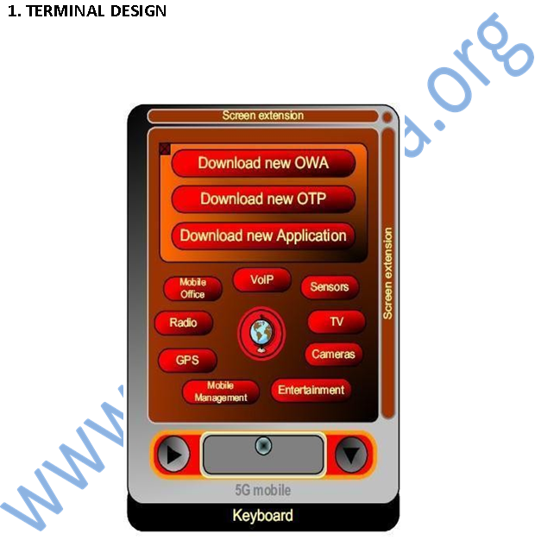

**Fig. Mobile Terminal Design of 5G**

#### **2. COMPARISION WITH OSI MODEL**

Let us compare the protocol stack of 5G wireless with the OSI Model using the fig. below.

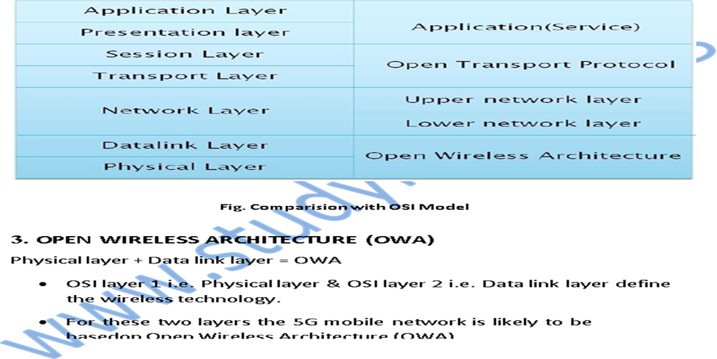

**4. NETWORK LAYER**

* All mobile networks will use mobile IP.
* Each mobile terminal will be FA (Foreign Agent).
* A mobile can be attached to several mobiles or wireless networks at the same time.
* The fixed IPv6 will be implemented in the mobile phones.
* Separation of network layer into two sub-layers: (i) Lower network layer (for each interface) (ii) Upper network layer (for the mobile terminal)

1. **OPEN TRANSPORT PROTOCOL (OTP)**

Transport layer + Session layer = OTP

• Wireless network differs from wired network regarding the transport layer.

• In all TCP versions the assumption is that lost segments are due to network congestion.

• In wireless, the loss is due to higher bit error ratio in the radio interface.

• 5G mobile terminals have transport layer that is possible to be downloaded & installed which is based on Open Transport Protocol.

1. **APPLICATION LAYER**

Presentation layer + Application layer = Application layer (5G)

• Provides intelligent QoS (Quality of Service) management over variety of networks.

• Provides possibility for service quality testing & storage of measurement information in information database in the mobile terminal.

• Select the best wireless connection for given services.

• QoS parameters, such as, delay, losses, BW, reliability, will be stored in DB (Database) of 5G mobile.

1. **FUNCTIONAL ARCHITECTURE**

Below figure shows the system model that proposes design of network architecture for 5G mobile systems, which is all-IP based model for wireless and mobile networks interoperability. The system consists of a user terminal (which has a crucial role in the new architecture) and several independent, autonomous radio access technologies. Within each of the terminals, each of the radio access technologies is seen as the IP link to the outside Internet world. However, there should be different radio interface for each Radio Access Technology (RAT) in the mobile terminal. For an example, if we want to have access to four different RATs, we need to have four different access - specific interfaces in the mobile terminal, and to have all of them active at the same time, with aim to have this architecture to be functional applications and servers somewhere on the Internet. Routing of packets should be carried out in accordance with established policies of the user.

Application connections are realized between clients and servers in the Internet via sockets. Internet sockets are endpoints for data communication flows. Each socket of the web is a unified and unique combination of local IP address and appropriate local transport communications port, target IP address and target appropriate communication port, and type of transport protocol. Considering that, the establishment of communication from end-to-end between the client and server using the Internet protocol is necessary to raise the appropriate Internet socket uniquely determined by the application of the client and the server. This means that in case of interoperability between heterogeneous networks and for the vertical handover between the respective radio technologies, the local IP address and destination IP address should be fixed and unchanged. Fixing of these two parameters should ensure handover transparency to the Internet connection end-to-end, when there is a mobile user at least on one end of such connection. In order to preserve the proper layout of the packets and to reduce or prevent packets losses, routing to the target destination and vice versa should be uniquely and using the same path. Each radio access technology that is available to the user in achieving connectivity with the relevant radio access is presented with appropriate IP interface. Each IP interface in the terminal is characterized by its IP address and net mask and parameters associated with the routing of IP packets across the network. In regular inter-system handover, the change of access technology (i.e., vertical handover) would mean changing the local IP address. Then, change of any of the parameters of the socket means and change of the socket, that is, closing the socket and opening a new one. This means, ending the connection and starting e new one. This approach is not-flexible, and it is based on today’s Internet communication. In order to solve this deficiency, we propose a new level that will take care of the abstraction levels of network access technologies to higher layers of the protocol stack. This layer is crucial in the new architecture. To enable the functions of the applied transparency and control or direct routing of packets through the most appropriate radio access technology, in the proposed architecture we introduce a control system in the functional architecture of the networks, which works in complete coordination with the user terminal and provides a network abstraction functions and routing of packets based on defined policies. At the same time this control system is an essential element through which it can determine the quality of service for each transmission technology. He is on the Internet side of the proposed architecture, and as such represents an ideal system to test the qualitative characteristics of the access technologies, as well as to obtain a realistic picture regarding the quality that can be expected from applications of the user towards a given server in Internet (or peer). Protocol setup of the new levels within the existing protocol stack, which form the proposed architecture, is presented in Figure (Protocol Layout for the Elements of the Proposed Architecture). The network abstraction level would be provided by creating IP tunnels over IP interfaces obtained by connection to the terminal via the access technologies available to the terminal (i.e., mobile user). In fact, the tunnels would be established between the user terminal and control system named here as Policy Router, which performs routing based on given policies. In this way the client side will create an appropriate number of tunnels connected to the number of radio access technologies, and the client will only set a local IP address which will be formed with sockets Internet communication of client applications with Internet servers. The way IP packets are routed through tunnels, or choosing the right tunnel, would be served by policies whose rules will be exchanged via the virtual network layer protocol. This way we achieve the required abstraction of the network to the client applications at the mobile terminal. The process of establishing a tunnel to the Policy Router, for routing based on the policies, are carried out immediately after the establishment of IP connectivity across the radio access technology, and it is initiated from the mobile terminal Virtual Network-level Protocol. Establishing tunnel connections as well as maintaining them represents basic functionality of the virtual network level (or network level of abstraction).

**CHAPTER V: HARDWARE AND SOFTWARE OF 5G**

1. **HARDWARE OF 5G**

• It uses UWB (Ultra-Wide Band) networks with higher BW at low energy levels.

• This BW is of 4000 Mbps, which is 400 times faster than today’s wireless networks.

• It uses smart antenna either Switched Beam Antennas or Adaptive Array Antennas.

• It uses CDMA (Code Division Multiple Access).

1. **SOFTWARE OF 5G**

• 5G will be single unified standard of different wireless networks, including LAN technologies, LAN/WAN, WWWW- World Wide Wireless Web, unified IP & seamless combination of broadband.

• Software defined radio, Packet layer, Implementation of Packets, Encryption, Flexibility, Anti-Virus.

**CHAPTER VI: FEATURES, ADVANTAGES & APPLICATIONS**

1. **FEATURES**

* 5G technology offer high resolution for crazy cell phone user and bidirectional large bandwidth shaping.
* The advanced billing interfaces of 5G technology makes it more attractive and effective.
* 5G technology also providing subscriber supervision tools for fast action.
* The high-quality services of 5G technology based on Policy to avoid error.
* 5G technology is providing large broadcasting of data in Gigabit which supporting almost 65,000 connections.
* 5G technology offer transporter class gateway with unparalleled consistency.
* The traffic statistics by 5G technology makes it more accurate.
* Through remote management offered by 5G technology a user can get better and fast solution. www.studymafia.org
* The remote diagnostics also a great feature of 5G technology.
* The 5G technology is providing up to 25 Mbps connectivity speed.
* The 5G technology also support virtual private network.
* The new 5G technology will take all delivery service out of business prospect.
* The uploading and downloading speed of 5G technology touching the peak.
* The 5G technology network offering enhanced and available connectivity just about the world.

**6.2 ADVANTAGES**

* 5G provides data bandwidth of 1 Gbps or higher.
* 5G is globally accessible.
* 5G provides dynamic information access beneficial to domestic user.
* 5G is available at low cost.

**6.3 APPLICATIONS**

* Wearable device with AI capabilities.
* Pervasive (Global) networks.
* Media independent handover.
* Radio resource management.
* High Altitude Stratospheric Platform Station (HAPS) systems.
* VoIP (Voice over IP) enabled device.

**CHAPTER VII: CONCLUSION**

* 3G- Operator Centric, 4G- Service Centric whereas 5G- User Centric
* We have proposed 5G wireless concept designed as an open platform on different layers.
* A new revolution of 5G technology is going to give tough completion to normal computer and laptops whose marketplace value will be affected.
* The new coming 5G technology is available in the market in affordable rates, high peak future and much reliability than its preceding technologies.
* This technology helps to promotes stronger links between people working in different fields creating future concepts of mobile communication, internet services, cloud computing, all pie network, and nanotechnology.

**References**

[1] en.wikipedia.org/wiki/5G

[2] Google.com

[3] Studymafia.org

[4] Pptplanet.com